VAMSI 192011429

EXPERIMENT 11

Functionalities of TCP, UDP

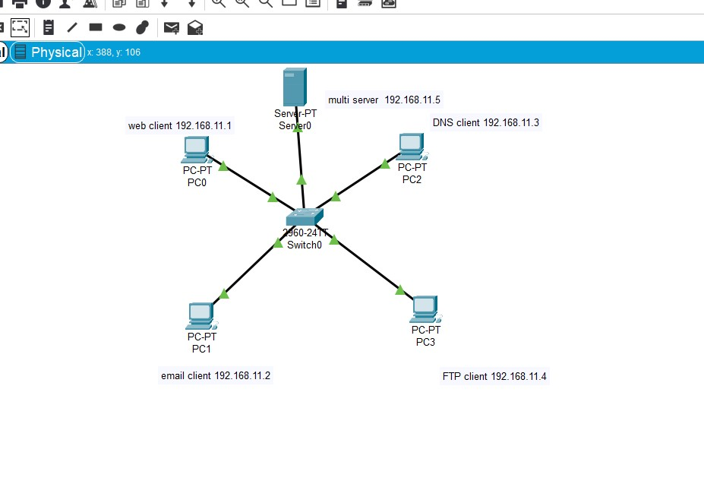

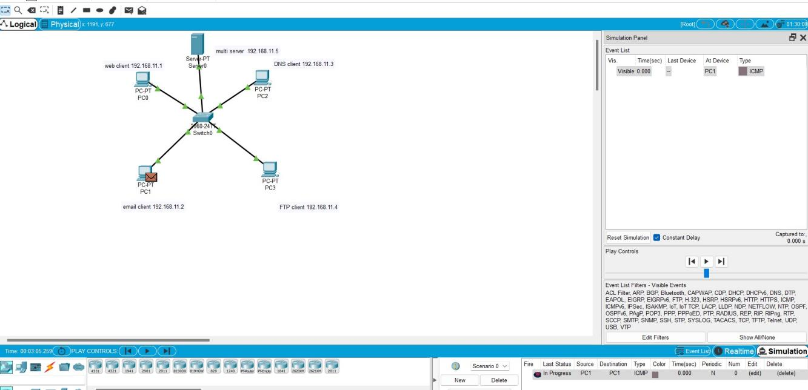

RESULT: the excepted out we have gotten…